Project Proposal and Implementation Plan: Real-Time ECG Arrhythmia Detector
Course: EEE 4407 Random Signals and Processes

1. Executive Summary
This document outlines the proposal, architecture, and execution plan for a real-time Electrocardiogram (ECG) Arrhythmia Detector. By leveraging concepts from stochastic processes, hypothesis testing, and random variable estimation, this project will model normal cardiac rhythms as Wide Sense Stationary (WSS) stochastic processes. Anomalies (arrhythmias) will be detected using statistical significance testing and Markov Chain state transitions. The implementation will be strictly done in MATLAB, utilizing the globally recognized MIT-BIH Arrhythmia Database for real-world physiological data.

2. Theoretical Framework & Syllabus Mapping
This project is specifically designed to satisfy the rigorous mathematical requirements of EEE 4407. The following table maps the course syllabus directly to our engineering application to ensure approval from the instructor:
Syllabus Topic | Application in Project | MATLAB Implementation / Mathematical Objective
Wide Sense Stationary (WSS) Processes | Modeling normal heartbeat behavior. | Extracting R-R intervals and proving that the mean and autocorrelation are time-invariant for a healthy patient over a specific window.
Confidence Intervals & Point Estimates | Defining the mathematical bounds of a "normal" heart rate. | Calculating the sample mean and variance of the R-R interval to establish a 95% or 99% confidence threshold.
Significance Testing (Hypothesis Testing) | Detecting irregular beats in real-time. | Null Hypothesis (H0): The incoming beat belongs to the normal distribution.  Alternative (H1): Anomaly detected (Reject H0).
Markov Chains | Modeling disease state transitions. | Defining transition probability matrices between states like "Normal Sinus Rhythm", "Premature Ventricular Contraction (PVC)", and "Fibrillation".

3. System Architecture
The system pipeline follows a standard signal processing and statistical decision-making architecture. Each block represents a specific MATLAB module:
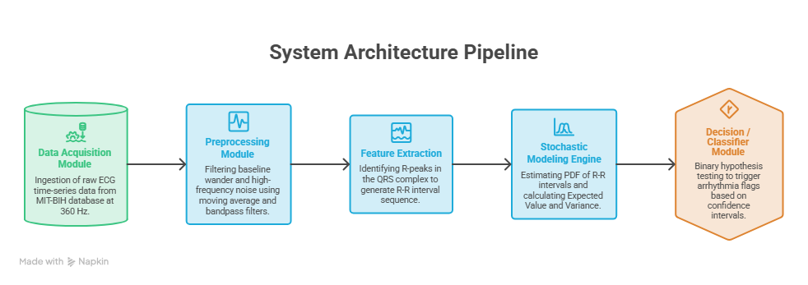

- Data Acquisition Module: Ingestion of raw ECG time-series data from the MIT-BIH database (sampled at 360 Hz).
- Preprocessing Module: Filtering baseline wander (respiration artifacts) and high-frequency noise using moving average and bandpass filters.
- Feature Extraction (QRS Detection): Identifying the R-peaks in the QRS complex to generate a random sequence of R-R interval times.
- Stochastic Modeling Engine: Estimating the Probability Density Function (PDF) of the R-R intervals and calculating the Expected Value and Variance dynamically.
- Decision / Classifier Module: Real-time binary hypothesis testing on incoming R-R data to trigger arrhythmia flags if it falls outside the confidence interval.

4. Project Timeline and Sprint Planning (5 Weeks)
With a 1-month+ deadline, the project is divided into distinct, manageable weekly sprints.
Phase | Duration | Key Deliverables | Milestones
Phase 1: Research & Data Prep | Week 1 | Download MIT-BIH dataset via PhysioNet, parse .dat/.hea files into MATLAB, plot raw random signals to visualize the noise. | Clean dataset successfully loaded into the MATLAB workspace.
Phase 2: Signal Processing | Week 2 | Implement the Pan-Tompkins algorithm or utilize MATLAB's findpeaks function to accurately extract R-R intervals. | Array of R-R intervals (Random Sequence) successfully extracted.
Phase 3: Stochastic Modeling | Week 3 | Estimate PDF, calculate Sample Mean, Variance, and establish Confidence Intervals. Test the sequence for WSS properties. | Statistical baseline established for "Healthy" vs "Arrhythmia".
Phase 4: Hypothesis Testing & Markov Chains | Week 4 | Write the decision logic (H0 vs H1) using MATLAB ttest or custom thresholding. Build the Markov transition matrix for patient states. | Working detection algorithm with quantifiable accuracy (True Positives vs False Positives).
Phase 5: UI & Final Report | Week 5+ | Create a simple MATLAB App Designer GUI to visualize the ECG and highlight anomalies in real-time. Draft the final academic report. | Project completion, ready for final presentation.

5. Team Roles and Responsibilities
To ensure equal distribution of work and grading among the 3 members, the project is divided into three core domains:
- Member 1: Signal Processing Lead - Focuses on data ingestion, noise filtering, and accurate QRS peak detection. Responsible for mastering the MATLAB Signal Processing Toolbox.
- Member 2: Stochastic Process & Math Lead - Focuses on estimating the probability density functions, calculating expected values and confidence intervals, and defining the Markov Chain transition matrices.
- Member 3: Statistical Testing & Integration Lead - Focuses on writing the binary hypothesis testing algorithms, evaluating false positive/negative rates, and building the final MATLAB visualization/App Designer GUI.

6. Key MATLAB Functions & Toolboxes Needed
The team should familiarize themselves with the following MATLAB functions before starting the coding phase:
% --- Signal Processing Toolbox ---
findpeaks() % For R-peak detection in the ECG signal
butter() % For designing bandpass filters to remove noise
filtfilt() % Zero-phase digital filtering to avoid phase distortion
% --- Statistics and Machine Learning Toolbox ---
normfit() % Parameter estimation (mean, standard deviation) for Gaussian models
ttest() % For statistical significance testing (Hypothesis Testing)
histogram() % To visualize the Probability Density Function (PDF)
hmmestimate() % For Markov Chain transition matrix estimation

7. Risk Management & Mitigations
- Data Complexity: The MIT-BIH dataset can be difficult to parse initially. Mitigation: Use PhysioNet's official WFDB Toolbox for MATLAB to easily read the physiological files directly into variables.
- High False Positive Rate: Arrhythmia detection algorithms can incorrectly trigger on simple artifacts (like patient movement). Mitigation: Tighten the confidence intervals and ensure the signal-to-noise ratio is handled meticulously during the Phase 2 preprocessing stage.

